ЛАБОРАТОРНА РОБОТА № 2

Тема: Породжувальні шаблони

Мета: навчитися реалізовувати породжувальні шаблони проєктування

Хід роботи:

Завдання 1:
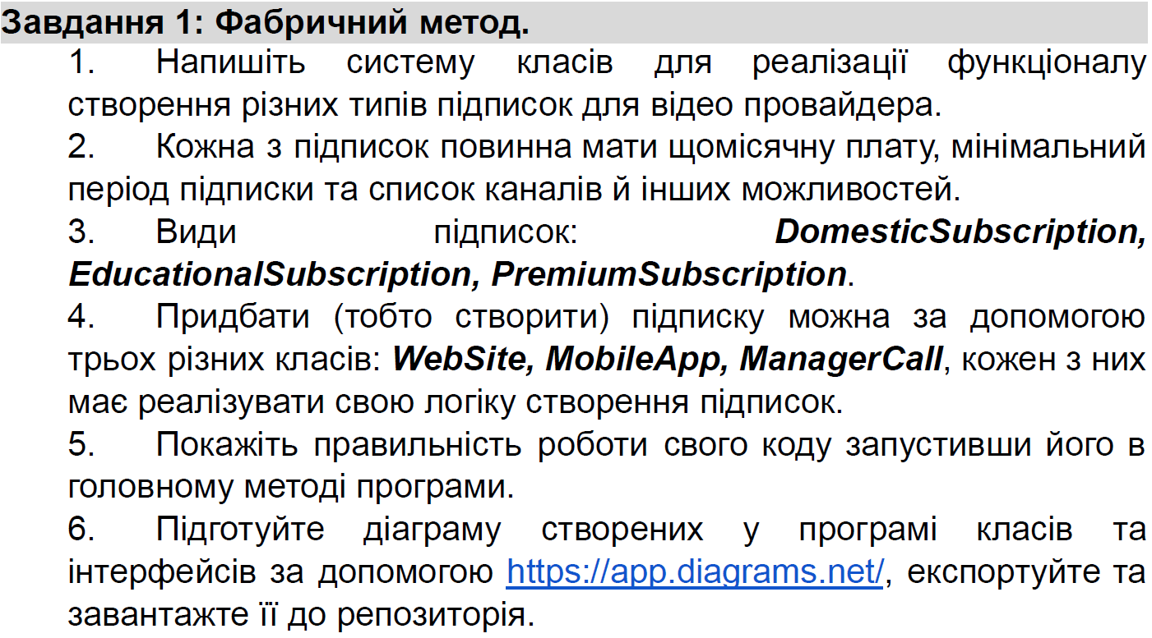
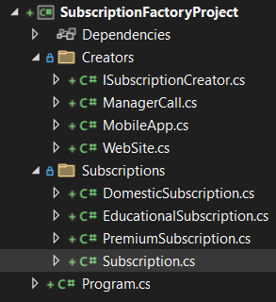
Рис. 1 Структура проекту
Program.cs:
using SubscriptionFactoryProject.Creators;
using SubscriptionFactoryProject.Subscriptions;

class Program
{
static void Main()
{
ISubscriptionCreator website = new WebSite();
ISubscriptionCreator mobileApp = new MobileApp();
ISubscriptionCreator managerCall = new ManagerCall();

Subscription sub1 = website.CreateSubscription("Domestic");
Subscription sub2 = mobileApp.CreateSubscription("Premium");
Subscription sub3 = managerCall.CreateSubscription("Educational");

Console.WriteLine(sub1);
Console.WriteLine(sub2);
Console.WriteLine(sub3);
}
}

Subscription.cs:
using System;
using System.Collections.Generic;
using System.Linq;
using System.Text;
using System.Threading.Tasks;

namespace SubscriptionFactoryProject.Subscriptions
{
public abstract class Subscription
{
public string Name { get; protected set; }
public decimal MonthlyFee { get; protected set; }
public int MinPeriod { get; protected set; }
public List<string> Features { get; protected set; }

protected Subscription(string name, decimal monthlyFee, int minPeriod, List<string> features)
{
Name = name;
MonthlyFee = monthlyFee;
MinPeriod = minPeriod;
Features = features;
}

public override string ToString()
{
return $"Subscription: {Name}, Fee: {MonthlyFee:C}, Min Period: {MinPeriod} months, Features: {string.Join(", ", Features)}";
}
}
}

DomesticSubscription.cs:
using System;
using System.Collections.Generic;
using System.Linq;
using System.Text;
using System.Threading.Tasks;

namespace SubscriptionFactoryProject.Subscriptions
{
public class DomesticSubscription : Subscription
{
public DomesticSubscription() : base("Domestic", 9.99m, 6, new List<string> { "Basic Channels", "HD Available" }) { }
}
}

EducationalSubscription.cs:
using System;
using System.Collections.Generic;
using System.Linq;
using System.Text;
using System.Threading.Tasks;

namespace SubscriptionFactoryProject.Subscriptions
{
public class EducationalSubscription : Subscription
{
public EducationalSubscription() : base("Educational", 6.99m, 3, new List<string> { "Educational Channels", "No Ads" }) { }
}
}

PremiumSubscription.cs:
using System;
using System.Collections.Generic;
using System.Linq;
using System.Text;
using System.Threading.Tasks;

namespace SubscriptionFactoryProject.Subscriptions
{
public class PremiumSubscription : Subscription
{
public PremiumSubscription() : base("Premium", 19.99m, 12, new List<string> { "All Channels", "4K Streaming", "Exclusive Content" }) { }
}
}

ISubscriptionCreator.cs:
using System;
using System.Collections.Generic;
using System.Linq;
using System.Text;
using System.Threading.Tasks;
using SubscriptionFactoryProject.Subscriptions;

namespace SubscriptionFactoryProject.Creators
{
public interface ISubscriptionCreator
{
Subscription CreateSubscription(string type);
}
}

ManagerCall.cs:
using SubscriptionFactoryProject.Subscriptions;
using System;
using System.Collections.Generic;
using System.Linq;
using System.Text;
using System.Threading.Tasks;

namespace SubscriptionFactoryProject.Creators
{
public class ManagerCall : ISubscriptionCreator
{
public Subscription CreateSubscription(string type)
{
return type switch
{
"Domestic" => new DomesticSubscription(),
"Educational" => new EducationalSubscription(),
"Premium" => new PremiumSubscription(),
_ => throw new ArgumentException("Invalid subscription type")
};
}
}
}

MobileApp.cs:
using SubscriptionFactoryProject.Subscriptions;
using System;
using System.Collections.Generic;
using System.Linq;
using System.Text;
using System.Threading.Tasks;

namespace SubscriptionFactoryProject.Creators
{
public class MobileApp : ISubscriptionCreator
{
public Subscription CreateSubscription(string type)
{
return type switch
{
"Domestic" => new DomesticSubscription(),
"Educational" => new EducationalSubscription(),
"Premium" => new PremiumSubscription(),
_ => throw new ArgumentException("Invalid subscription type")
};
}
}
}

WebSite.cs:
using SubscriptionFactoryProject.Subscriptions;
using System;
using System.Collections.Generic;
using System.Linq;
using System.Text;
using System.Threading.Tasks;

namespace SubscriptionFactoryProject.Creators
{
public class WebSite : ISubscriptionCreator
{
public Subscription CreateSubscription(string type)
{
return type switch
{
"Domestic" => new DomesticSubscription(),
"Educational" => new EducationalSubscription(),
"Premium" => new PremiumSubscription(),
_ => throw new ArgumentException("Invalid subscription type")
};
}
}
}
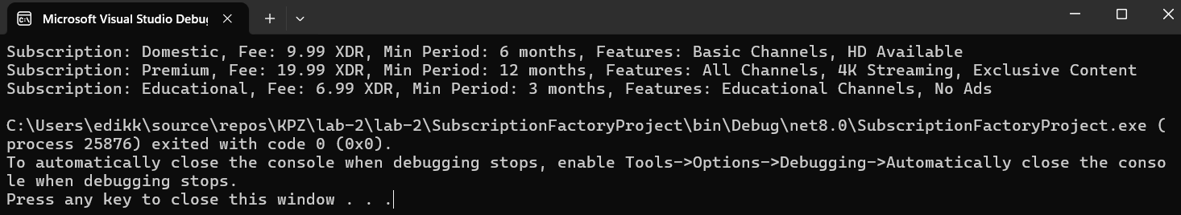
Рис. 2 Результат виконання завдання
Завдання 2:
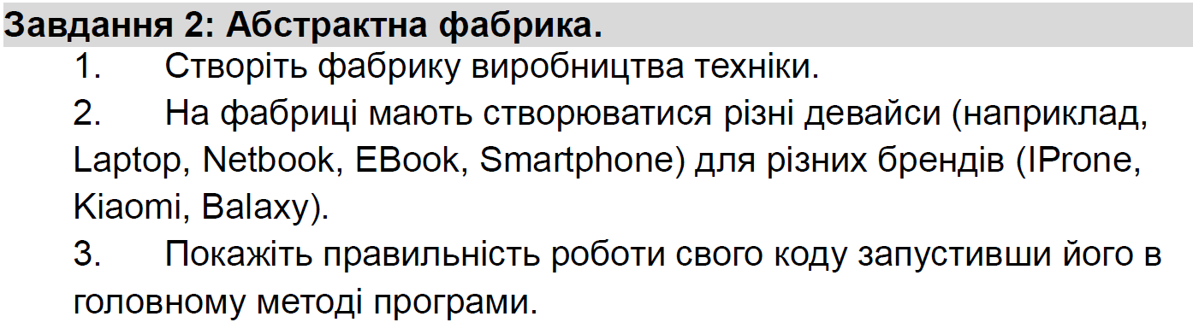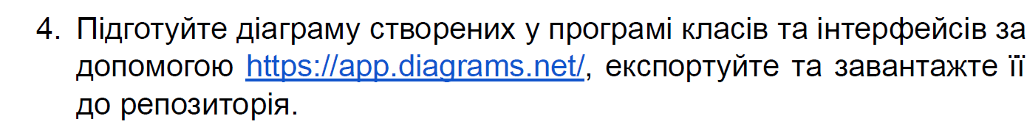

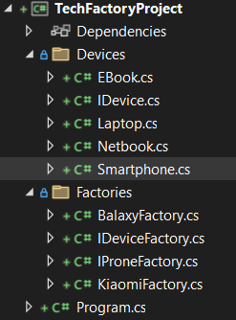
Рис. 3 Структура проекту
Program.cs:
using System;
using TechFactoryProject.Factories;
using TechFactoryProject.Devices;

class Program
{
static void Main()
{
TestFactory(new IProneFactory());
TestFactory(new KiaomiFactory());
TestFactory(new BalaxyFactory());
}

static void TestFactory(IDeviceFactory factory)
{
Console.WriteLine($"Testing {factory.GetType().Name}:");
IDevice laptop = factory.CreateLaptop();
IDevice netbook = factory.CreateNetbook();
IDevice ebook = factory.CreateEBook();
IDevice smartphone = factory.CreateSmartphone();

Console.WriteLine(laptop.GetName());
Console.WriteLine(netbook.GetName());
Console.WriteLine(ebook.GetName());
Console.WriteLine(smartphone.GetName());
Console.WriteLine();
}
}

BalaxyFactory.cs:
using System;
using System.Collections.Generic;
using System.Linq;
using System.Text;
using System.Threading.Tasks;

using TechFactoryProject.Devices;

namespace TechFactoryProject.Factories
{
public class BalaxyFactory : IDeviceFactory
{
public IDevice CreateLaptop() => new Laptop("Balaxy");
public IDevice CreateNetbook() => new Netbook("Balaxy");
public IDevice CreateEBook() => new EBook("Balaxy");
public IDevice CreateSmartphone() => new Smartphone("Balaxy");
}
}

IDeviceFactory.cs:
using System;
using System.Collections.Generic;
using System.Linq;
using System.Text;
using System.Threading.Tasks;

using TechFactoryProject.Devices;

namespace TechFactoryProject.Factories
{
public interface IDeviceFactory
{
IDevice CreateLaptop();
IDevice CreateNetbook();
IDevice CreateEBook();
IDevice CreateSmartphone();
}
}
IProneFactory.cs:
using System;
using System.Collections.Generic;
using System.Linq;
using System.Text;
using System.Threading.Tasks;

using TechFactoryProject.Devices;

namespace TechFactoryProject.Factories
{
public class IProneFactory : IDeviceFactory
{
public IDevice CreateLaptop() => new Laptop("IProne");
public IDevice CreateNetbook() => new Netbook("IProne");
public IDevice CreateEBook() => new EBook("IProne");
public IDevice CreateSmartphone() => new Smartphone("IProne");
}
}

KiaomiFactory.cs:
using System;
using System.Collections.Generic;
using System.Linq;
using System.Text;
using System.Threading.Tasks;

using TechFactoryProject.Devices;

namespace TechFactoryProject.Factories
{
public class KiaomiFactory : IDeviceFactory
{
public IDevice CreateLaptop() => new Laptop("Kiaomi");
public IDevice CreateNetbook() => new Netbook("Kiaomi");
public IDevice CreateEBook() => new EBook("Kiaomi");
public IDevice CreateSmartphone() => new Smartphone("Kiaomi");
}
}

EBook.cs:
using System;
using System.Collections.Generic;
using System.Linq;
using System.Text;
using System.Threading.Tasks;

namespace TechFactoryProject.Devices
{
public class EBook : IDevice
{
private string _brand;
public EBook(string brand) => _brand = brand;

public string GetName() => $"{_brand} E-Book";
}
}
IDevice.cs:
using System;
using System.Collections.Generic;
using System.Linq;
using System.Text;
using System.Threading.Tasks;

namespace TechFactoryProject.Devices
{
public interface IDevice
{
string GetName();
}
}

Laptop.cs:
using System;
using System.Collections.Generic;
using System.Linq;
using System.Text;
using System.Threading.Tasks;

namespace TechFactoryProject.Devices
{
public class Laptop : IDevice
{
private string _brand;
public Laptop(string brand) => _brand = brand;

public string GetName() => $"{_brand} Laptop";
}
}

Netbook.cs:
using System;
using System.Collections.Generic;
using System.Linq;
using System.Text;
using System.Threading.Tasks;

namespace TechFactoryProject.Devices
{
public class Netbook : IDevice
{
private string _brand;
public Netbook(string brand) => _brand = brand;

public string GetName() => $"{_brand} Netbook";
}
}
Smartphone.cs:
using System;
using System.Collections.Generic;
using System.Linq;
using System.Text;
using System.Threading.Tasks;

namespace TechFactoryProject.Devices
{
public class Smartphone : IDevice
{
private string _brand;
public Smartphone(string brand) => _brand = brand;

public string GetName() => $"{_brand} Smartphone";
}
}

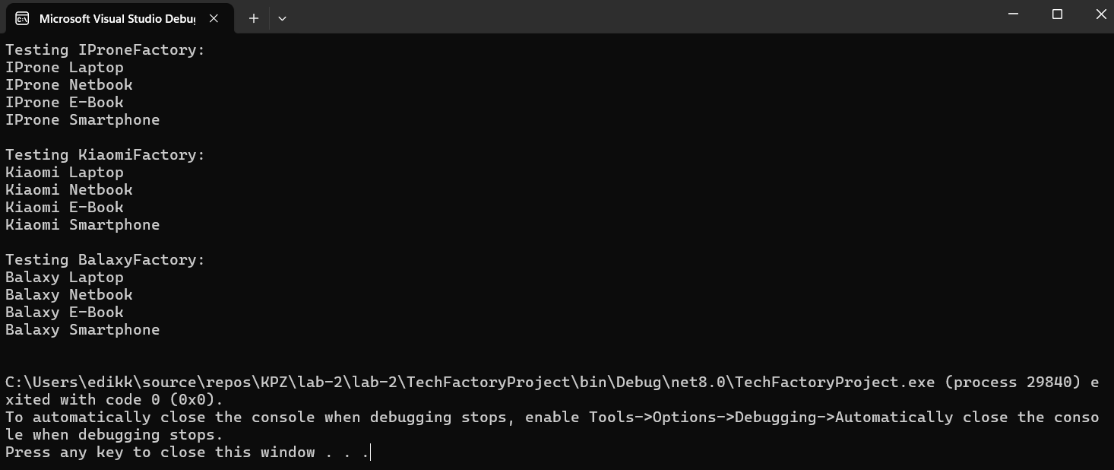
Рис. 4 Результат виконання завдання
Завдання 3:
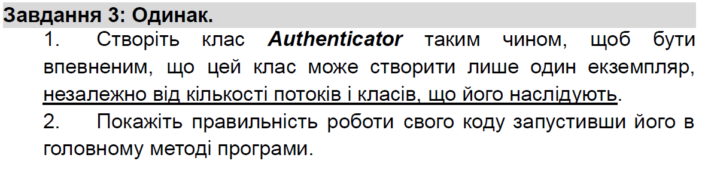

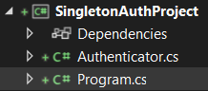
Рис. 5 структура проекту

Program.cs:
using System;
using System.Threading.Tasks;

namespace SingletonAuthProject
{
class Program
{
static void Main()
{
Parallel.Invoke(
() => PrintAuthenticatorInstance(),
() => PrintAuthenticatorInstance(),
() => PrintAuthenticatorInstance()
);
}

static void PrintAuthenticatorInstance()
{
Authenticator auth = Authenticator.GetInstance();
Console.WriteLine($"Authenticator Token: {auth.GetToken()}");
}
}
}
Authenticator.cs:
using System;

namespace SingletonAuthProject
{
public sealed class Authenticator
{
private static Authenticator? _instance;
private static readonly object _lock = new object();
private string _token;

private Authenticator()
{
_token = Guid.NewGuid().ToString();
}

public static Authenticator GetInstance()
{
if (_instance == null)
{
lock (_lock)
{
if (_instance == null)
{
_instance = new Authenticator();
}
}
}
return _instance;
}

public string GetToken() => _token;
}
}

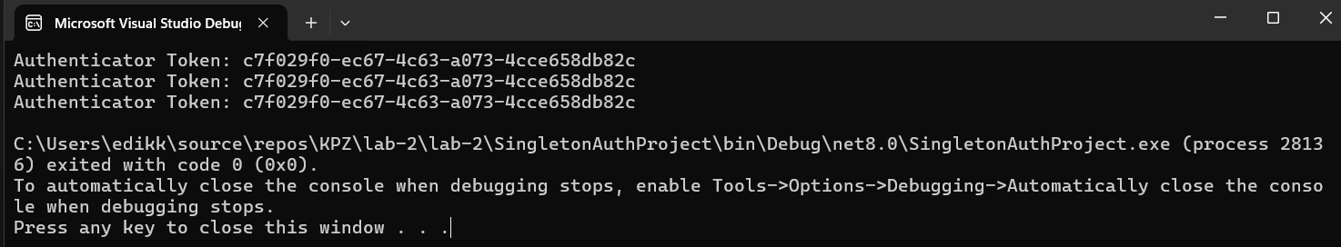
Рис. 6 Результат виконання завдання
Завдання 4:
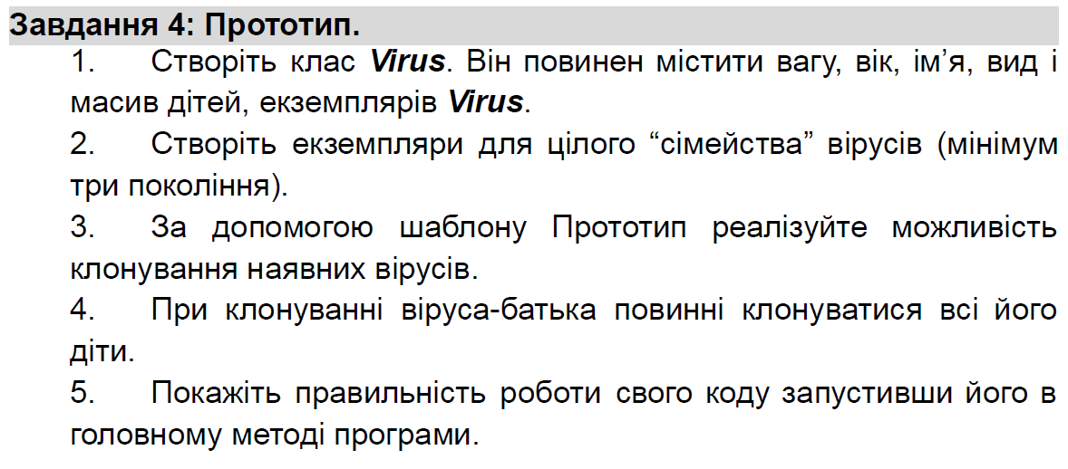

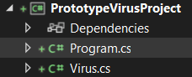
Рис. 7 Структура проекту

Program.cs:
using System;

namespace PrototypeVirusProject
{
class Program
{
static void Main()
{
Virus parentVirus = new Virus("Corona-X", "RNA", 2.5, 10);

Virus child1 = new Virus("Corona-X1", "RNA", 1.2, 5);
Virus child2 = new Virus("Corona-X2", "RNA", 1.1, 4);
parentVirus.AddChild(child1);
parentVirus.AddChild(child2);

Virus grandChild1 = new Virus("Corona-X1.1", "RNA", 0.6, 2);
child1.AddChild(grandChild1);

Console.WriteLine("Original Virus:");
parentVirus.Print();

Virus clonedVirus = parentVirus.Clone();
Console.WriteLine("\nCloned Virus:");
clonedVirus.Print();
}
}
}

Virus.cs:
using System;
using System.Collections.Generic;

namespace PrototypeVirusProject
{
public class Virus
{
public string Name { get; set; }
public string Type { get; set; }
public double Weight { get; set; }
public int Age { get; set; }
public List<Virus> Children { get; set; }

public Virus(string name, string type, double weight, int age)
{
Name = name;
Type = type;
Weight = weight;
Age = age;
Children = new List<Virus>();
}

public void AddChild(Virus child)
{
Children.Add(child);
}

public Virus Clone()
{
Virus clonedVirus = new Virus(Name, Type, Weight, Age);
foreach (var child in Children)
{
clonedVirus.Children.Add(child.Clone());
}
return clonedVirus;
}

public void Print(int level = 0)
{
Console.WriteLine($"{new string('-', level * 2)}> {Name} ({Type}), {Weight}g, {Age} days old");
foreach (var child in Children)
{
child.Print(level + 1);
}
}
}
}
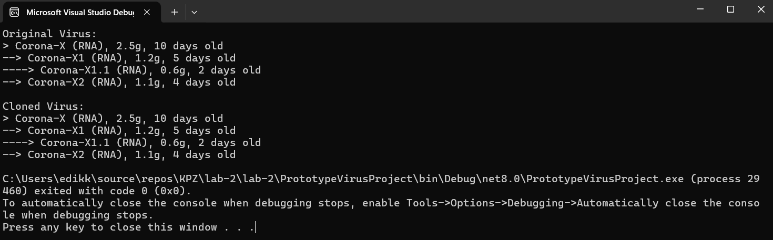
Рис. 8 Результат виконання завдання

Завдання 5:
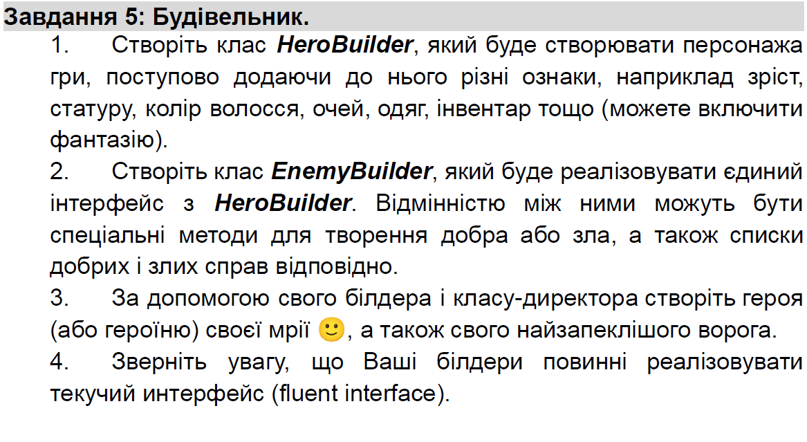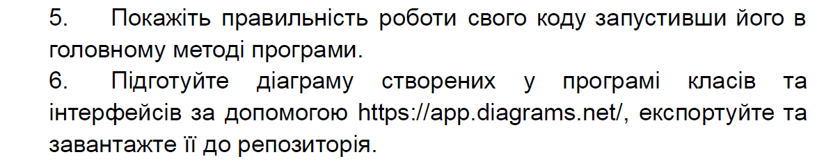
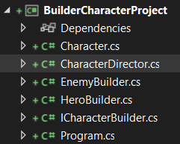
Рис. 9 Структура проекту

Program.cs:
using System;

namespace BuilderCharacterProject
{
class Program
{
static void Main()
{
CharacterDirector director = new CharacterDirector();

ICharacterBuilder heroBuilder = new HeroBuilder();
Character hero = director.CreateHero(heroBuilder);

ICharacterBuilder enemyBuilder = new EnemyBuilder();
Character enemy = director.CreateEnemy(enemyBuilder);

Console.WriteLine(hero);
Console.WriteLine(enemy);
}
}
}

ICharacterBuilder.cs:
using System;
using System.Collections.Generic;
using System.Linq;
using System.Text;
using System.Threading.Tasks;

namespace BuilderCharacterProject
{
public interface ICharacterBuilder
{
ICharacterBuilder SetName(string name);
ICharacterBuilder SetAppearance(string appearance);
ICharacterBuilder SetWeapon(string weapon);
ICharacterBuilder AddAbility(string ability);
Character Build();
}
}

HeroBuilder.cs:
using System;
using System.Collections.Generic;
using System.Linq;
using System.Text;
using System.Threading.Tasks;

namespace BuilderCharacterProject
{
public class HeroBuilder : ICharacterBuilder
{
private Character _character = new Character { Role = "Герой" };

public ICharacterBuilder SetName(string name)
{
_character.Name = name;
return this;
}

public ICharacterBuilder SetAppearance(string appearance)
{
_character.Appearance = appearance;
return this;
}

public ICharacterBuilder SetWeapon(string weapon)
{
_character.Weapon = weapon;
return this;
}

public ICharacterBuilder AddAbility(string ability)
{
_character.Abilities.Add(ability);
return this;
}

public Character Build()
{
return _character;
}
}
}

EnemyBuilder.cs:
using System;
using System.Collections.Generic;
using System.Linq;
using System.Text;
using System.Threading.Tasks;

namespace BuilderCharacterProject
{
public class EnemyBuilder : ICharacterBuilder
{
private Character _character = new Character { Role = "Лиходiй" };

public ICharacterBuilder SetName(string name)
{
_character.Name = name;
return this;
}

public ICharacterBuilder SetAppearance(string appearance)
{
_character.Appearance = appearance;
return this;
}

public ICharacterBuilder SetWeapon(string weapon)
{
_character.Weapon = weapon;
return this;
}

public ICharacterBuilder AddAbility(string ability)
{
_character.Abilities.Add(ability);
return this;
}

public Character Build()
{
return _character;
}
}
}

CharacterDirector.cs:
using System;
using System.Collections.Generic;
using System.Linq;
using System.Text;
using System.Threading.Tasks;

namespace BuilderCharacterProject
{
public class CharacterDirector
{
public Character CreateHero(ICharacterBuilder builder)
{
return builder.SetName("Артемiс")
.SetAppearance("Високий, срiбне волосся")
.SetWeapon("Меч долi")
.AddAbility("Швидкiсть")
.AddAbility("Телепортацiя")
.Build();
}

public Character CreateEnemy(ICharacterBuilder builder)
{
return builder.SetName("Моргат")
.SetAppearance("Темний плащ, палаючi очi")
.SetWeapon("Жезл хаосу")
.AddAbility("Некромантiя")
.AddAbility("Прокляття")
.Build();
}
}
}

Character.cs:
using System;
using System.Collections.Generic;

namespace BuilderCharacterProject
{
public class Character
{
public string Name { get; set; }
public string Role { get; set; }
public string Appearance { get; set; }
public string Weapon { get; set; }
public List<string> Abilities { get; set; } = new List<string>();

public override string ToString()
{
return $"{Role}: {Name}\nЗовнiшнiсть: {Appearance}\nЗброя: {Weapon}\nВмiння: {string.Join(", ", Abilities)}\n";
}
}
}

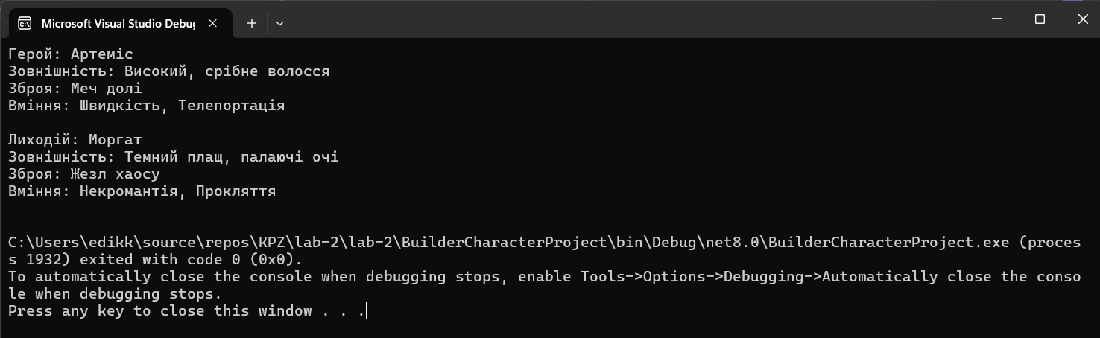
Рис. 10 Результат виконання завдання

Висновки: я навчитися реалізовувати породжувальні шаблони проєктування

Посилання на GitHub: https://github.com/EduardKrutii/KPZ_labs

